# Experiment #2 – Differential Amplifiers

**Last update: 2018A**

**22.02.18**

## Objectives

Understand differential amplifiers: differential- and common-mode analysis.

Understand auxiliary circuitry: current mirrors, emitter degeneration.

Analyze multi-stage amplifiers.

Build, measure, and analyze an amplifier in feedback configuration.

Maximum time allotted for this experiment: 7 hours.

## Recommended sources

1. Sedra Adel, S. Kenneth, C. Smith. Microelectronic Circuits, 6th Ed., New York, Oxford. Chap 8 (only BJT circuits are relevant), Chap 11 (sections 11.4, 11.8.1).
2. Millman, C., C. Halkias. Integrated Electronics Chap 15, 16.

## Mandatory reading/viewing (files available on our Moodle website)

1. “INFOBIT - How to measure a spectrum”
2. “INFOBIT - The XY mode”

## Your personal tour guide

* In your preparatory report, you will analyze the circuits used in the experiment.
* The purpose of the purple text is to give you an overview of what you’re doing – why are you analyzing this circuit? How does it relate to the other circuits? What is the purpose?

1. Preliminary questions and general review

* In this experiment, you may assume that for all transistors , except if:  
  (a) noted otherwise, or (b) you are asked to calculate the resistance of a current mirror.



Figure 1

* 1. Given the differential amplifier in Figure 1 above, develop and write down the formulas for the following quantities, in parametric form. Express your answers in terms of  or , , and the resistor names only, and assume , , and both transistors are forward-active.
* **Note: in this experiment, we define** ** and** **. By “double-sided output”, we mean the output is taken differentially, i.e. not relative to ground. For common-mode input, use .**
  + 1. Differential input resistance, , seen by source  (draw the source directly on Figure 1 as it is and show calculation).
    2. Common-mode input resistance, , seen by source  (draw the source directly on Figure 1 as it is and show calculation).
    3. Single-side output differential gain, 
    4. Double-sided output differential gain, 
    5. Single-side output common-mode gain, 
    6. Double-sided output common-mode gain, 
    7. CMRR, both in V/V and dB
* Note: by default, we *always* define CMRR for a double-sided output, unless the circuit has only one output.
  + 1. The relative sensitivity  (defined as: ). Also explain what is this figure of merit. For this section *only*, assume  are much larger than the resistance into the bases of Q1,Q2 to ease your calculation.
* Driving the differential amplifier in Figure 1, is a non-ideal current source (marked in a rectangle). The actual implementation of this source may vary.
  1. In Figure 1, the nonideal source has current Ix and resistance Rx. We marked the current into the nonideal source as “I”. What is the *theoretic* condition on the value of Rx such that Ix=I? Using the resistor values in Figure 1, find the *practical* condition such that Ix≈I.
* In some of the following sections you will be required to choose numerical values for hand-calculations or simulations. If you have a lab partner, the last three digits of yours and your partner’s ID number will hence be referred to as “ABC” and “DEF”, respectively. If you are attending the lab alone, use your last six digits, i.e. “ABCDEF”.

|  |  |  |
| --- | --- | --- |
|  |  |  |
| (a) | (b) | (c) |
| Figure 2  **For the circuits above, R3=R4=1k****Ω, R=12kΩ+ABDE, and V+=-V-=15V.**  **The transistors have a small signal parameter:** ,  is equal for all transistors, and can be considered large for calculations of Rx *only*. | | |

Current source implementation #1: resistor implementation: Figure 2(a)

* We expect a *nonlinear response* when using a resistor as a current source implementation, because the bias point changes slightly with the input, which means the gain changes as well. The next sections will guide you through this notion.
  1. Assume the differential amplifier is zero-biased (), and find the current I and resistance Rx (in Figure 1). Calculate  for this case.
  2. Now assume , and that Q1,Q2 are still forward-active. Find the current I and resistance Rx (in Figure 1). Calculate  for this case.
  3. According to the previous sections, *qualitatively explain* how would the output  look if the amplifier’s input  is a 2Vpp sine wave.

Current source implementation #2: current mirror: Figure 2(b)

* 1. Find the current I and resistance Rx (in Figure 1) of this current mirror. What is the current transfer ratio, , of this mirror ( is the current through R)?
  2. What is the advantage of this current source over implementation #1? In your answer, refer to the resistance and the case where the input is not zero-biased (e.g. ).

Current source implementation #3: Figure 2(c)

* This current mirror “with base-current compensation” is covered in Sedra & Smith. It is worth reading about so you can answer this section appropriately.
  1. Find the current I and resistance Rx (in Figure 1) for this current mirror. What is the current transfer ratio, , of this mirror ( is the current through R)?
  2. What is the advantage of this current source over implementation #2? In your answer, refer to the resistance and the current transfer ratio, and the effect of Q5.

Current source implementation #3-2:

* 

Figure 3

* The improved circuit in Figure 2(c) was sent to mass production, but evidently with a tiny change. You will now analyze the circuit in Figure 3. The value of R is as defined above.
* This is the implementation used in experiment!
  1. Find the current I and resistance Rx (in Figure 1) for this current mirror. What is the current transfer ratio, , of this mirror ( is the current through R)?
  2. What is the difference in this current source over implementation #3? In your answer, refer to the resistance and the current transfer ratio.

1. Lab practicalities

|  |  |
| --- | --- |
|  |  |
| (a) “Differential-input differential amplifier” | (b) “Single-ended-fed differential amplifier” |
| Figure 4 | |

* 1. For the circuit in Figure 4(a), explain the concept of “virtual ground”. What are the conditions for its validity?
* Since we usually cannot produce two inputs as in Figure 4(a), differential circuits are often fed with single-ended inputs, such as in Figure 4(b).
* However, in the experiment, we would like to measure the differential-mode gain. To do this, could we use Figure 4(b), and assume it is *approximately* “differential mode”? Let’s analyze it.
  1. Why is the circuit in Figure 4(b) not strictly in “differential mode”?
  2. Is there a “virtual ground” in Figure 4(b)? Explain.
  3. What is the condition required of Rx such that, approximately, virtual ground exists in Figure 4(b)? Hint: virtual ground, the equal division of  on the two B-E junctions (i.e.  and ), the currents  and , and Rx are all related. Explain this relationship.
  4. Conclude: when can the gain measured from Figure 4(b) be approximated as the differential gain of the circuit?
  5. Why can we NOT take the two leads of the waveform generator, and connect one to  and the other to , thereby implementing a pure differential input  and having the amplifier in differential mode?
* Well, your conclusion so far should be – yes! To measure a differential circuit in differential mode, we should use Figure 4(b). However, things are not so simple.
* 

Figure 5

* 1. The schematic block in Figure 5 describes the double-ended differential amplifier in Figure 1, with the base resistors RB1, RB2, of course. Explain how this relates to Figure 4(b) in AC analysis, and then explain why this circuit is not balanced in DC analysis. Why is an unbalanced bias point a problem?
* One solution to this imbalance is to *directly* connect vg to vin1, and connect vin2 to ground, exactly as is depicted in Figure 4(b). While this is OK in theory where vg is assumed to be small enough such that it doesn’t disturb the bias point, this might not be the case in practice. We could use this configuration if: the circuit’s design takes this into account, or the consequences are negligible, or if we are willing to accept the consequences of this configuration’s drawbacks.

THD and spectrum measurement

* In the experiment you will have to use the scope’s FFT function to display and measure the spectral content of a signal. Read “INFOBIT – How to measure a spectrum” on our lab’s website and answer the following questions.
  1. Given a square wave with base frequency AB kHz, what would the Span be in order to have the first 5 harmonics displayed on screen? What would be considered a “good FFT resolution” in this case?
  2. Denoting the harmonics of a spectrum , where  is the first harmonic, the scope will measure these in dBV, i.e. .. Setting the scope correctly, you will be able to measure the harmonics in dB. Explain the difference and explain how you would do this using the scope.
* Once you have the values of the harmonics in dB, you’ll be able to calculate the total harmonic distortion, or THD. If you measured all harmonics relative to the first harmonic, then the formula would be,



* where  is the measurement of the mth harmonic from the scope.
  1. Suppose you have a square wave input between -1V and 1V, and you take its spectrum using the scope. Explain how would the spectrum look like for a duty cycle of 50%, and for a duty cycle of 33.33%.

1. Circuit analysis: Double-Ended Differential Amplifier

* Refer to the experimental procedure, sections ‎1 and ‎2.

|  |  |
| --- | --- |
|  |  |
| (a) Double-Ended Differential Amplifier | (b) Block diagram with RC link |
| Figure 6  **NOTICE**: the 30k resistors in (b) are R14 and R31 in (a). | |

* Using this circuit, you will compare the performance of a differential amplifier driven with different current source implementations.
* The block diagram in Figure 6(b) is how we will measure the **differential gain** of this circuit. In the preliminary report, you will analyze its performance for later comparison.
* Note that the capacitors C11, C12, and C13 are currently disconnected from the circuit. An equivalent capacitor “Cx”, which may be any combination of these, is marked in (b).
* In the following sections and in future experiments, you may be asked to simulate a circuit in PSPICE. When providing a simulation output, **you must always include the circuit you built** in PSPICE, with bias point markers (V/I) on it. Graphs without a circuit attached to them will not be given grade, as well as the sections analyzing them.
* Unless otherwise instructed, in PSPICE always use model Q2N2222 for NPN and Q2N3906 for PNP BJT transistors. Note that Bode graphs must always include amplitude (in dB) and phase (in degrees).
* Also, **you must decide** on the correct frequency range to present (recall that you compare these to SWEEP measurements in the experiments, thus the frequency range must be chosen for practical purposes).

Using a **resistor** implementation for a current source: Figure 2(a)

* 1. For symmetry reasons, make sure you always attach R31 to vin2.
  2. According to Figure 6(b), which of the outputs  or  will be the inverting output, , and which the non-inverting output ?
  3. Simulate Figure 6(b) in PSPICE and draw a Bode plot for  and , on the same graph, but in different Y axis (use Plot->Add Y Axis). According to the bias point simulation, what are the DC voltages ,?
  4. Choose an intermediate frequency and mark the gain values on the graph (using PSPICE label). Mark also the frequencies defining the bandwidth of each transfer function.
  5. Rebuild Figure 6(b) in simulation, but make the change such that the you’d be able to measure the *common mode gain*. Make sure the 100Ω and 22uF RC link is still connected. Can you tell which output is inverting and which is non-inverting in this case? Explain!
  6. Rerun the simulation and draw a Bode plot for  and , on the same graph, but in different Y axis. Use the same frequency range you used in section ‎3.3.
  7. Mark the intermediate gain values at the same frequency as in section ‎3.4.
  8. Calculate the CMRR of the differential amplifier in V/V and dB in the frequency you chose.

Using **current mirror** implementation #3-2: Figure 3

* In essence, you will now repeat most of the previous sections, but with a different current source implementation. We will *concisely* repeat the instructions for your convenience:
  1. Simulate this circuit in PSPICE and draw a Bode plot for  and , on the same graph, but in different Y axis. Mark the gain in intermediate frequencies and the bandwidth.
  2. Rebuild the circuit in *common-mode*, and draw a Bode plot for  and , on the same graph, but in different Y axis. Use the same frequency range you used in section ‎3.9. Also mark the intermediate gain values at the same frequency. Make sure the 100Ω and 22uF RC link is still connected.

* 1. Calculate the CMRR of the differential amplifier in V/V and dB in the frequency you chose.

1. Frequency response of a differential amplifier in common mode

* Refer to the experimental procedure, sections ‎4.

|  |  |
| --- | --- |
|  |  |
| (a) Resistor with capacitance, theory | (b) Resistor with capacitance, experiment |
| Figure 7 | |

* The frequency behavior of the differential amplifier in Figure 6(b), under common mode excitation, can be modeled by introducing a dominant capacitance Css in the current source driving the differential amplifier, as depicted in Figure 7(a).
  1. For the circuit in Figure 6(b), when in common mode (review section ‎3.5 above), find the frequency dependent transfer function, , assuming the current source is implemented using Figure 7(a). What are the expressions for the zeros and poles of this function?
  2. For this section only, assume in Figure 6, that  and neglect , and simplify  from the previous section. Also simplify the poles and zeros.
  3. Draw a qualitative Bode graph for the gain of . Mark the location of the zeros and poles you calculated, in Hz, assuming Css=3nF (Rx is an unknown parameter).
  4. In the experiment, you will implement a dominant capacitance using Figure 7(b). Qualitatively explain the differences between Figure 7(a) and Figure 7(b) in DC and AC analyses.
  5. Also, in the experiment there will always be poles dominating the transfer function’s high frequency range. Explain how this would affect an experimental frequency sweep of . Draw an example.
  6. Lastly, in the experiment, suppose that you have a gain function with an LPF shape. You know how to measure its -3dB point. Explain *concisely* how would you measure the +3dB point for an HPF gain function.

1. Circuit analysis: Single-Ended Differential Amplifier

* Refer to the experimental procedure, sections ‎5.

|  |  |
| --- | --- |
|  |  |
| (a) Single-Ended Differential Amplifer | (b) Block diagram with added resistors |
| Figure 8  **The transistors have a small signal parameter:** ,  is equal for all transistors, and can be considered large for calculations of the current source’s resistance *only*. | |

* Since this circuit will only be used later as an amplification stage in our home-made operational amplifier, here we will have a short analysis of it.
* In the following, assume , and make approximations where appropriate.
  1. The current source in Figure 8(a) is only partially shown. TP37 connects in a certain way to part of the circuitry in Figure 3, to form a current mirror. Draw the complete, correct current mirror, and as in previous sections show calculation for the current I and resistance Rx (in Figure 1). You may use results derived in previous sections, of course.
  2. What is the advantage of this current mirror over the one in Figure 3?
  3. Assume that the two differential amplifiers are now cascaded, i.e. Figure 6’s outputs are connected to Figure 8’s inputs, (Figure 6)(Figure 8) and (Figure 6)(Figure 8). What is the output bias voltage , at the circuit’s bias point?
  4. Calculate the single-ended differential gain of this circuit, .
  5. Calculate the single-ended common-mode gain of this circuit, .
* **For the following subsections ONLY, assume the power supplies are set to +/-5V.**
  1. Assume a DC input, , as is depicted in Figure 14. Calculate the maximal and minimal values, , in which all transistors are forward active and in approximately-equal bias point.
  2. Explain how would the output look like for a sine input with an amplitude of /1kHz/0V offset. Draw a *qualitative* example of such an input and the corresponding output, and refer to the different operation regimes of a transistor in your explanation. Hint: don’t forget your answer in ‎5.5 above.

1. Circuit analysis: Amplifying Buffer Output Stage

|  |  |
| --- | --- |
|  |  |
| (a) Amplifying Buffer Output Stage | (b) Block diagram |
| Figure 9 | |

* As the last stage in a multistage amplifier, the output stage should have characteristic qualities. The following sections will help you understand them.
* The amplifying buffer output stage is built of two sections: a voltage amplifier, and a buffer input Class AB output stage, also known as a *power amplifier* stage.
* In the following, assume the output stage and single-ended amplifier are cascaded, such that Figure 6Figure 8 as before and (Figure 8)(Figure 9). Also assume , and make appropriate approximations.
  1. What is the value of the potentiometer P3 such that the output DC voltage is zero, at the circuit’s bias point?
  2. Estimate the voltage gain of the voltage amplifier section, .
* While the subject of Output Stages is well covered in Experiment 4, here we have an input buffer class AB output stage. It is a good idea to read the relevant chapters in Sedra & Smith (see bibliography).
  1. Estimate the input resistance of the input buffer part, , as marked on the drawing.
  2. Estimate the output resistance of the circuit, assuming no input signal.
  3. Concisely explain how the output stage operates. In your explanation, indicate the advantages of using the input buffer part, the importance of the output resistance, and expand on the term “push-pull” (up to 6 lines for this answer).

1. Three-stage operational amplifier

* Refer to the experimental procedure, section ‎6.

|  |  |
| --- | --- |
| (a) |  |
| (b) |  |
|  | Figure 10  **NOTICE**: the 30k resistors in (a) are R14 and R31. |

* The schematic in Figure 10(b) represents a 3-stage operational amplifier, constructed from the block diagram in Figure 10(a).
* For the 3-stage op-amp, you will use the **current mirror implementation** to drive the double-ended differential amplifier.
  1. In Figure 10(a), the inputs to the 3-stage opamp are “vin1” and “vin2”. In Figure 10(b), we marked the two inputs as “vin-“ (the inverting input) and “vin+” (the non-inverting input). Explain: which of the inputs “vin1” and “vin2” is inverting, and which is non-inverting?
  2. Using the previous sections, calculate the opamp’s differential gain .
  3. Assuming the maximum output voltage swing for linear operation is 6Vpp, what is the maximal differential input, , in Vpp?
  4. According to your answers in the previous three sections, and your experience from Experiment 1: Operational Amplifiers, why can’t you measure the open-loop gain of this 3-stage opamp directly? how would you measure it in the lab? Use Figure 15 for reference, and write down all the steps required.
* At home, review the relevant section in the experiment (section ‎6). Make sure you know how to measure the open-loop gain in the lab!

# Experimental procedure

|  |  |  |  |
| --- | --- | --- | --- |
| 19 | B36-11 | 308177815 | Alon moses |
| 204301758 | Ido debi |
| **Booth number** | **Board number** | **Student IDs** | **Your names** |

Reminder:

1. **All the answers for the practical and theoretical questions shall be written down in this document, during lab hours only.**
2. **Save this file as “report2_XXX_YYY” when XXX, YYY are your students ID’s. Please save this document right now as to avoid any future inconvenience.**
3. **At the end of this lab you must upload this file under the right assignment to the course site and click “hand in assignment”:**

**• If you have yet to complete this experiment in its entirety, please upload the file under the “Progress report” assignment.**

**• If you had completed this experiment and answered all of the questions, please upload the file under the “Post lab (Final)” assignment.**

1. **You cannot “fix” sections that have been answered without a special approval from your lab instructors.**
2. **You should not attempt to upload or send the assignments from your home or after/before lab hours.**
3. Double-ended differential amplifier, resistor implementation

* Refer to the preliminary report, section ‎3.

Build the circuit in Figure 6(b), according to the preliminary report, using the resistor implementation. The circuit schematic is redrawn here for your convenience:



Figure 11

Measuring Rx

* **Do NOT attempt to directly measure resistance (using the multimeter’s “Ω2” function) unless explicitly instructed to. You may damage the multimeter!**
* We will begin by measuring Rx. Since it is “unhealthy” for the multimeter to measure resistance in active networks (there may be large currents injected into it through TP35), here we will perform an implicit measurement and then calculate it.
* Hint: remember that the multimeter always measures in RMS – either DC or AC.
  1. Measure the following bias point voltages:

|  |  |  |
| --- | --- | --- |
| -0.667V | -0.668V | -0.726V |
|  |  | TP35 |

* 1. Using these values, **calculate** Rx. Explain calculation and assumptions.

|  |
| --- |
| V/I=(15-0.726)/(0.824mA)=17.32Kohm |
| ביצענו KVL ממקור המתח התחתון עד לנגד Rx. כאשר את הזרם מדדנו באמצעות המולטימטר |

Evaluating the circuit

* 1. Set vg to a 100Hz-sine wave and choose the amplitude such that the circuit is operating linearly between input and output for all frequencies.
  2. Attach a print of a sweep, of vg and vout1, with VPP measurements for CH1 and CH2 (total of 2 measurements), and write down the sweep parameters in the table below.

|  |  |
| --- | --- |
| **SWEEP MEASUREMENT** | |
| Frequency range | 100Hz-4Mhz |
| Sweep time | 1sec |
| Input voltage | 100mVpp |

*Print: input and output sweep*

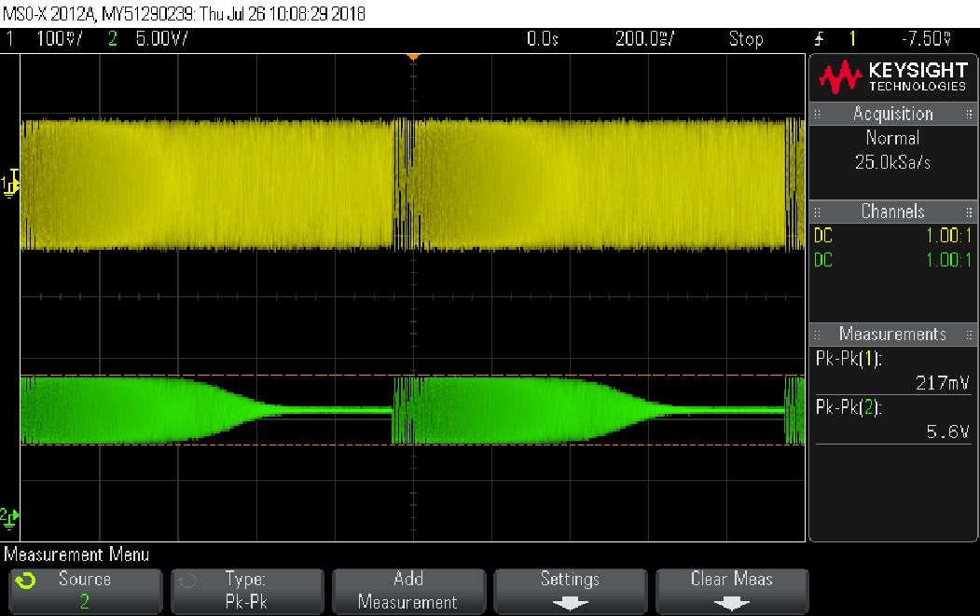

* 1. Find the -3dB frequency and attach a print of the input vin1 and output vout1 at this frequency, with frequency measurement for CH1, VPP measurements for CH1 and CH2, and a phase measurement (total of 4 measurements). Make sure that both signals are not larger than half the screen.

*Print: input and output*

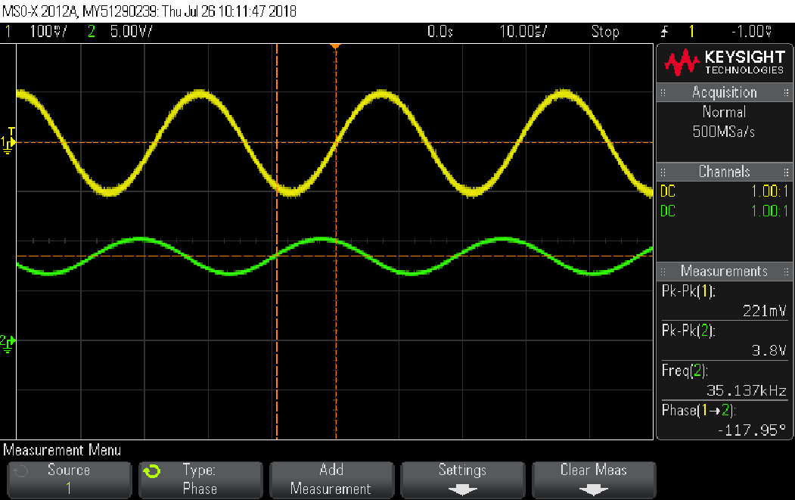

Measuring CMRR

* 1. You will now measure the *differential gain* of the circuit, for CMRR calculation later. To do this, do the following:
     1. Connect the scope’s CH1 to the board’s CH1 using a BNC cable, and measure .
     2. Connect the scope’s CH2 to the board’s CH2 using a BNC cable, and measure .
     3. On the scope, use the MATH function, and display the *differential output*  on screen, together with  and , by using the correct mathematical operator.
* Hint: use the two knobs to the right of the “MATH” button to set the scale and offset of the MATH graph.
  + 1. Attach a print of both outputs  and , and the resulting , all in the same scale as your print in section ‎1.5, with VPP measurements for CH1, CH2, and MATH, and with RMS measurement for MATH (total of 4 measurements). Use the same frequency you found there.

*Print: outputs  and , and , at -3dB frequency*

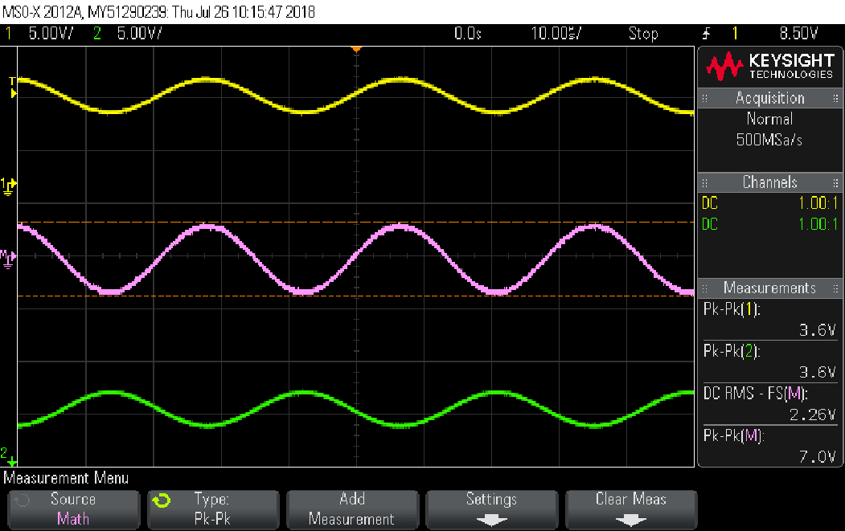

* + 1. Connect a BNC-pins cable to the multimeter, and **carefully** connect the pins to measure the *differential input* , as shown in the following photo:

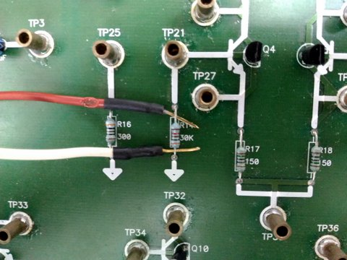

Figure 12

* **Think!** What is the type of measurement you are performing with the multimeter? Is it RMS? VPP? MEAN? Should it be in AC coupling, or DC coupling?
* **Think some more!** Why is this connection equivalent to measuring the differential input? What are the assumptions and approximations we make here? Review the preliminary report if you do not know the answers.
  1. Complete the following table with measurements for calculating the double-sided output differential gain, .

|  |  |  |  |
| --- | --- | --- | --- |
| **TABLE MEASUREMENT** | | | |
|  |  |  |  |
| 1000 | 0.0666 | 3.62 | 34.70 |
| 34000 | 0.0728 | 2.24 | 29.76 |
| 36000 | 0.0728 | 2.16 | 29.45 |
| 40000 | 0.0727 | 2.02 | 28.88 |
| 60000 | 0.0727 | 1.5 | 26.29 |
| 80000 | 0.0727 | 1.17 | 24.13 |
| 100000 | 0.0727 | 0.961 | 22.42 |
| 150000 | 0.0727 | 0.67 | 19.29 |
| (3dB frequency=28kHz) | 0.0728 | 2.5 | 30.72 |
| 1kHz (see section ‎1.7.1) | 0.0666 | 3.62 | 34.70 |

* + 1. Attach a print of both outputs  and , and the resulting , at 1kHz, with the same measurement type and coupling you chose to use in the table above. Make sure these measurements are added to the table above.

*Print: outputs  and , and , at 1kHz, differential mode*

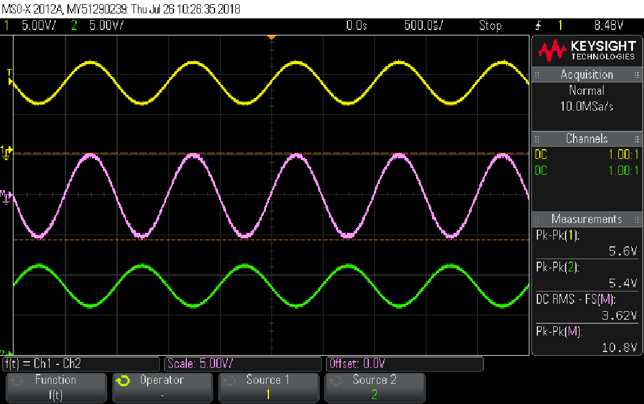

* 1. Now, change the circuit so you measure in *common mode*.
* Tip #1: recall how you measured common mode in Experiment 1: Operational Amplifiers. What is the required connection? How would the circuit behave? What is required of the input signal amplitude?
  + 1. Attach a print of a sweep, of vg and vout1, with VPP measurements for CH1 and CH2 (total of 2 measurements), and write down the sweep parameters in the table below.

|  |  |
| --- | --- |
| **SWEEP MEASUREMENT** | |
| Frequency range | 100Hz-1MHz |
| Sweep time | 1sec |
| Input voltage | 2Vpp |

*Print: input and output sweep, common input*

נ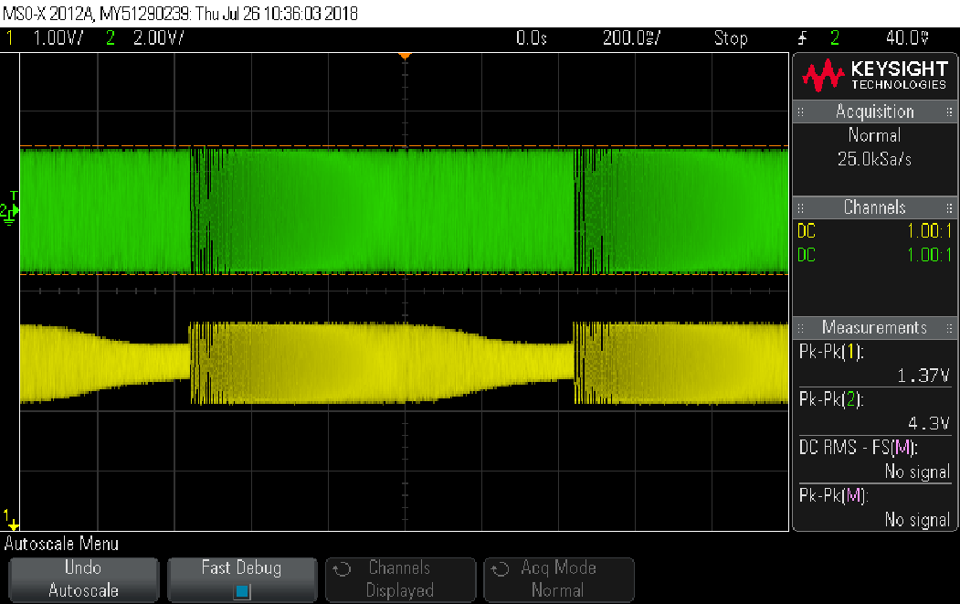

* + 1. **Use the same frequencies you measured in ‎1.7!** And fill the table.
* Tip #2: it is okay to change the input amplitude between frequencies as long as the circuit is still operating linearly!

|  |  |  |  |
| --- | --- | --- | --- |
| **TABLE MEASUREMENT** | | | |
|  |  |  |  |
| 1000 | 1.4 | 0.087 | -24.13 |
| 34000 | 1.4 | 0.084 | -24.44 |
| 36000 | 1.4 | 0.084 | -24.44 |
| 40000 | 1.4 | 0.082 | -24.65 |
| 60000 | 1.4 | 0.081 | -24.75 |
| 80000 | 1.4 | 0.089 | -23.93 |
| 100000 | 1.4 | 0.087 | -24.13 |
| 150000 | 1.4 | 0.084 | -24.44 |
| (3dB frequency=28KHz) | 1.4 | 0.085 | -24.33 |
| 1kHz (see section ‎1.8.3) | 1.4 | 0.087 | -24.13 |

* + 1. Attach a print of both outputs  and , and the resulting , at 1kHz, with the measurement and coupling you chose to use in the table above. Make sure these measurements are added to the table above.

*Print: outputs  and , and , at 1kHz, common mode*

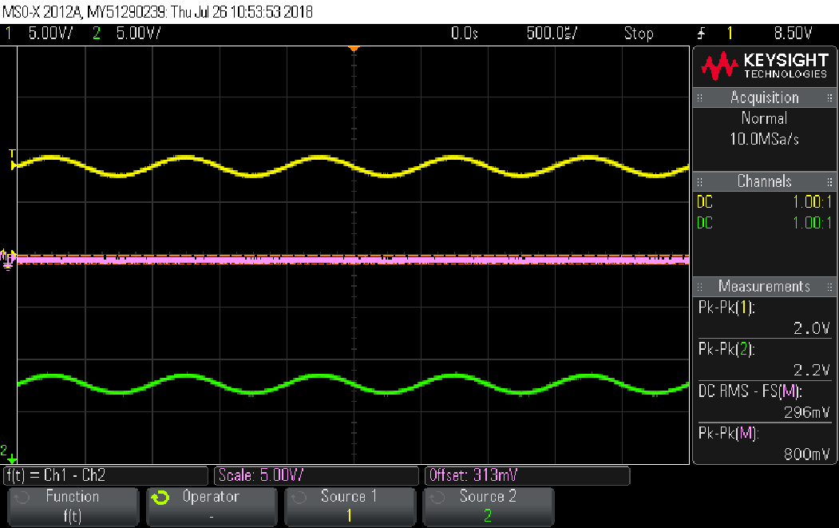

* 1. Using your previous measurements, calculate CMRR and graph it.

|  |  |  |  |
| --- | --- | --- | --- |
|  |  |  |  |
| 1000 | 34.70 | -23.74 | 58.44 |
| 34000 | 29.76 | -24.15 | 53.91 |
| 36000 | 29.45 | -23.29 | 52.74 |
| 40000 | 28.88 | -23.29 | 52.17 |
| 60000 | 26.29 | -22.50 | 48.79 |
| 80000 | 24.13 | -21.04 | 45.17 |
| 100000 | 22.42 | -21.16 | 43.58 |
| 150000 | 19.29 | -19.70 | 38.99 |
|  |  |  |  |
|  |  |  |  |

* Great! Now, we’re going to repeat the whole process, but with a different implementation of the current source driving the differential amplifier. Why? Because in the end you will be asked to compare between them and theory. Which is better? Let’s see!

1. Double-ended differential amplifier, current-mirror implementation

* Refer to the preliminary report, section ‎3.

Build the circuit in Figure 6(b), according to the preliminary report, using the current-mirror implementation. The circuit schematic is redrawn here for your convenience:



Figure 13

Measuring Ry

* **Do NOT attempt to directly measure resistance (using the multimeter’s “Ω2” function) unless explicitly instructed to. You may damage the multimeter!**
* We will begin by measuring Ry. Since it is “unhealthy” for the multimeter to measure resistance in active networks (there may be large currents injected into it through TP35), here we will perform an implicit measurement and then calculate it.
  1. Measure the following bias point voltages:

|  |  |  |
| --- | --- | --- |
| -0.698V | -0.698V | -0.777V |
|  |  | TP35 |

* 1. Using these values, **calculate** Ry. Explain calculation and assumptions.

|  |
| --- |
| -(-15+ 1.4)/I –R26 = 11.95Kohm || we did KVL from the Ry to V- |
| בעזרת מדידת זרם במולטימטר, הזרם בראי הזרם:1.05mA |

Evaluating the circuit

* 1. Set vg to a 100Hz-sine wave and choose the amplitude such that the circuit is operating linearly between input and output for all frequencies.
  2. Attach a print of a sweep, of vg and vout1, with VPP measurements for CH1 and CH2 (total of 2 measurements), and write down the sweep parameters in the table below.

|  |  |
| --- | --- |
| **SWEEP MEASUREMENT** | |
| Frequency range | 100hz-4MHz |
| Sweep time | 1sec |
| Input voltage | 100mVpp |

*Print: input and output sweep*

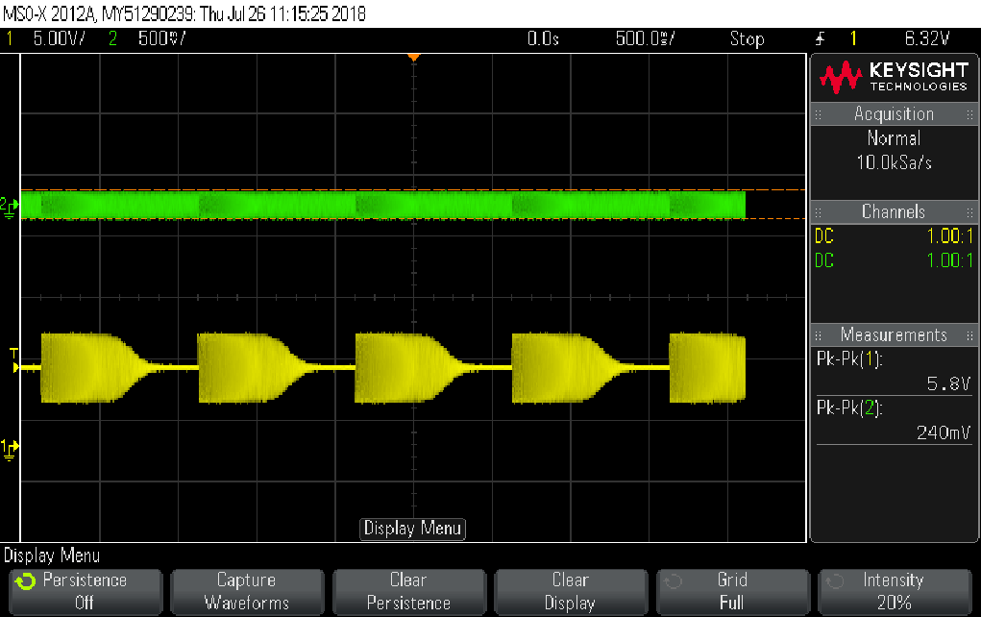

* 1. Find the -3dB frequency and attach a print of the input vin1 and output vout1 at this frequency, with frequency measurement for CH1, VPP measurements for CH1 and CH2, and a phase measurement (total of 4 measurements). Make sure that each signal is not larger than half the screen.

*Print: input and output*

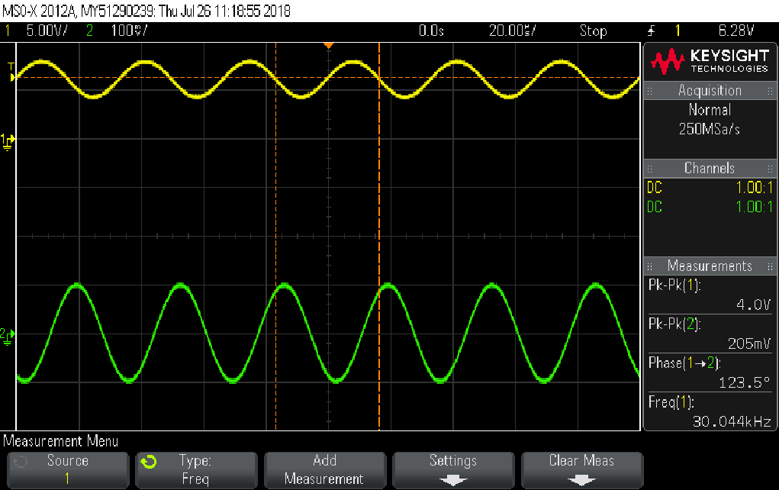

Measuring CMRR

* 1. You will now measure the *differential gain* of the circuit, for CMRR calculation later. To do this, do the following:
     1. Connect the scope’s CH1 to the board’s CH1 using a BNC cable, and measure .
     2. Connect the scope’s CH2 to the board’s CH2 using a BNC cable, and measure .
     3. On the scope, use the MATH function, and display the *differential output*  on screen, together with  and , by using the correct mathematical operator.
     4. Attach a print of both outputs  and , and the resulting , in the same scales as your print in section ‎2.5, with VPP measurements for CH1, CH2, and MATH, and with RMS measurement for MATH (total of 4 measurements).

*Print: outputs  and , and *

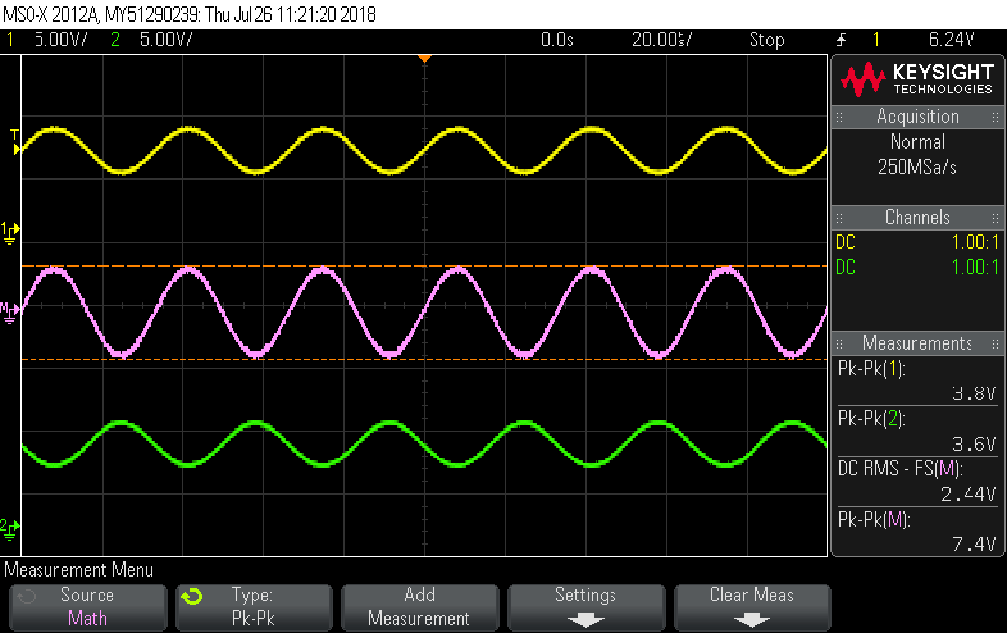

* + 1. Connect a BNC-pins cable to the multimeter, and **carefully** connect the pins to measure the *differential input* , as you did in section ‎1.6.5.
  1. Complete the following table with measurements for calculating the double-sided output differential gain, .

|  |  |  |  |
| --- | --- | --- | --- |
| **TABLE MEASUREMENT** | | | |
|  |  |  |  |
| 1000 | 0.0961 | 3.81 | 31.96 |
| 28000 | 0.0961 | 2.54 | 28.44 |
| 32000 | 0.0961 | 2.35 | 27.77 |
| 40000 | 0.0961 | 2.03 | 26.50 |
| 60000 | 0.0961 | 1.48 | 23.75 |
| 80000 | 0.096 | 1.16 | 21.64 |
| 100000 | 0.096 | 0.95 | 19.91 |
| 150000 | 0.096 | 0.676 | 16.95 |
| (3dB frequency=26KHz) | 0.0961 | 2.64 | 28.78 |
| 1kHz (see section ‎2.7.1) | 0.0961 | 3.81 | 31.96 |

* + 1. Attach a print of both outputs  and , and the resulting , at 1kHz, with the same measurement type and coupling you chose to use in the table above. Make sure these measurements are added to the table above.

*Print: outputs  and , and , at 1kHz, differential mode*

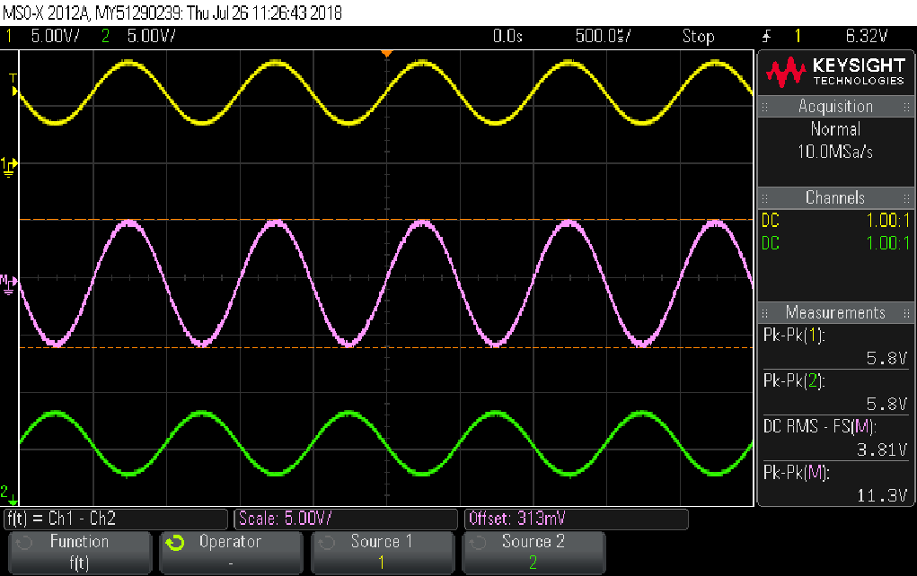

* 1. Now, change the circuit so you measure in *common mode*.
     1. Attach a print of a sweep, of vg and vout1, with VPP measurements for CH1 and CH2 (total of 2 measurements), and write down the sweep parameters in the table below.

|  |  |
| --- | --- |
| **SWEEP MEASUREMENT** | |
| Frequency range | 100Hz-1Mhz |
| Sweep time | 1sec |
| Input voltage | 4vpp |

*Print: input and output sweep, common input*

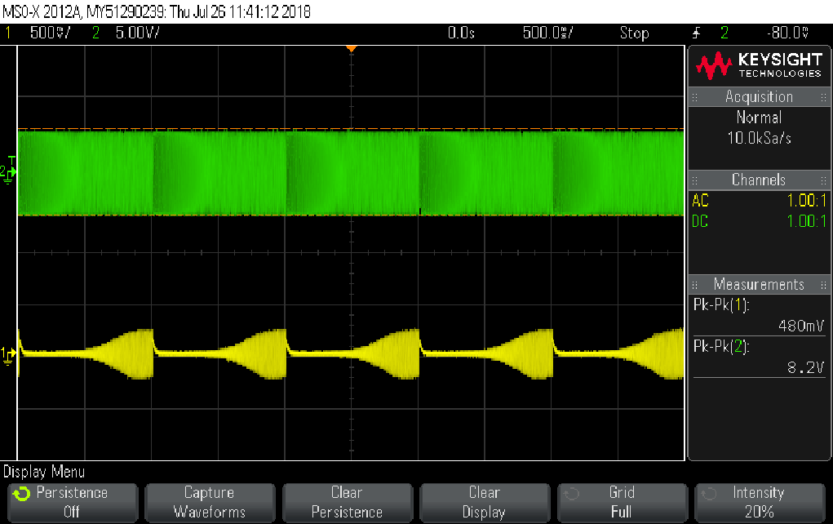

* If your measurements are seem very noisy, it is best to measure in RMS, which averages over the noise. However, you may also try to use the “High Resolution” function of the oscilloscope. What does it do?
  + 1. Look again at the time-dependent sine signal. Press “Acquire” -> “Acq. Mode” -> “High Resolution” and **hold it for at least 2 seconds** until a help window pops up on the oscilloscope screen. Write a short description of what this mode does.

|  |
| --- |
| במצב של רזולוציה גבוהה הסקופ מבצע דגימות נוספות, ומבצע עליהן ממוצע. המטרה של החישוב הזה הוא להראות תמונה חדה ויציבה יותר על גבי המסך. |
|  |

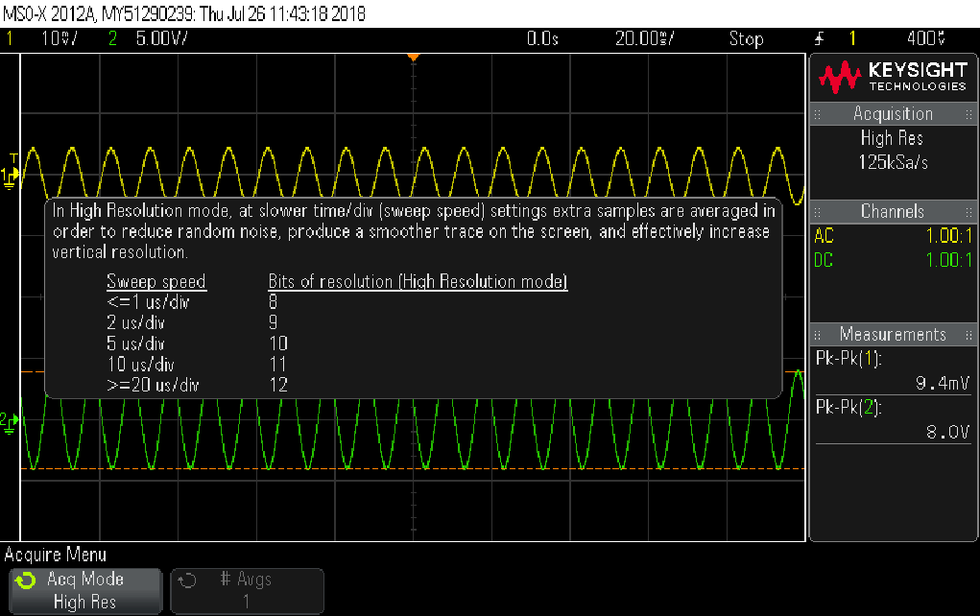

* + 1. Make sure High Resolution is enabled and retake the sweep measurement with the same sweep parameters. Think and discuss among yourselves: why is this happening? Is it always beneficial to use “High Res”? (no need to write an answer).

*Print: input and output sweep, common input*

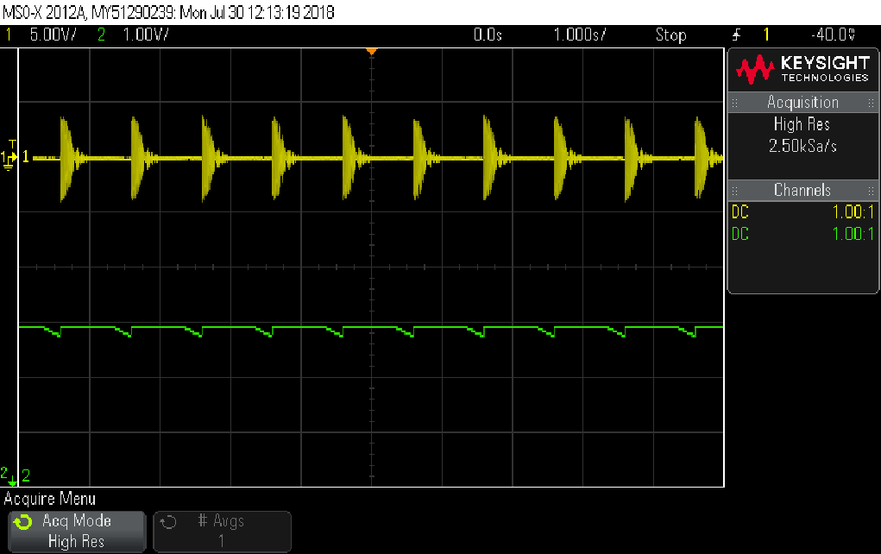

* + 1. Now disable the sweep and fill the following table. **Use the same frequencies you measured in ‎2.7!**

|  |  |  |  |
| --- | --- | --- | --- |
| **TABLE MEASUREMENT** | | | |
|  |  |  |  |
| 1000 | 2.8 | 0.054 | -34.30 |
| 28000 | 2.8 | 0.069 | -32.17 |
| 32000 | 2.8 | 0.072 | -31.80 |
| 40000 | 2.8 | 0.077 | -31.21 |
| 60000 | 2.8 | 0.085 | -30.35 |
| 80000 | 2.8 | 0.088 | -30.05 |
| 100000 | 2.81 | 0.09 | -29.89 |
| 150000 | 2.88 | 0.084 | -30.70 |
|  |  |  |  |
| 1kHz (see section ‎2.8.5) | 2.8 | 0.054 | -34.30 |

* + 1. Attach a print of both outputs  and , and the resulting , at 1kHz, with the measurement and coupling you chose to use in the table above.

*Print: outputs  and , and , at 1kHz, common mode*

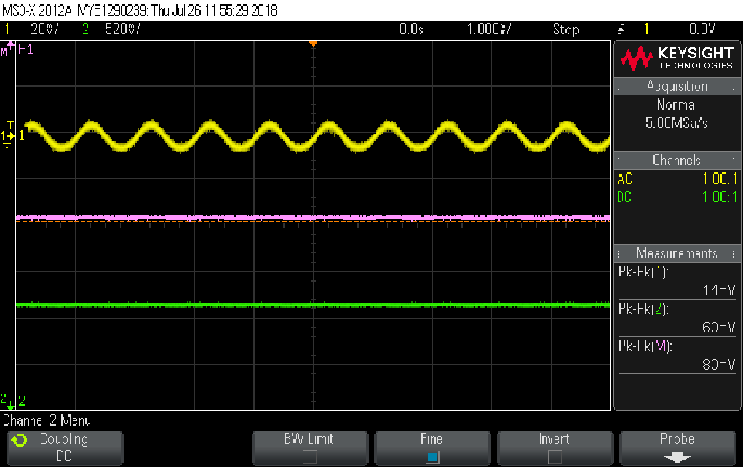

* 1. Using your previous measurements, calculate CMRR and graph it.

|  |  |  |  |
| --- | --- | --- | --- |
|  |  |  |  |
| 1000 | 31.96 | -34.30 | 66.26 |
| 28000 | 28.44 | -32.17 | 60.61 |
| 32000 | 27.77 | -31.80 | 59.57 |
| 40000 | 26.50 | -31.21 | 57.71 |
| 60000 | 23.75 | -30.35 | 54.1 |
| 80000 | 21.64 | -30.05 | 51.69 |
| 100000 | 19.91 | -29.89 | 49.8 |
| 150000 | 16.95 | -30.70 | 47.65 |
|  |  |  |  |
|  |  |  |  |

1. Comparison

* 1. Copy both CMRRs, for the resistor and current mirror implementations, and draw a graph with both curves. Also, fill the table below:
* Important tip: it is OK if the CMRRs do not share the same frequencies or even frequency range. Why should they?

|  |  |  |
| --- | --- | --- |
|  | (resistor) | (current mirror) |
| 1000 | 58.44 | 66.26 |
| 28000 | 53.91 | 60.61 |
| 32000 | 52.74 | 59.57 |
| 40000 | 52.17 | 57.71 |
| 60000 | 48.79 | 54.1 |
| 80000 | 45.17 | 51.69 |
| 100000 | 43.58 | 49.8 |
| 150000 | 38.99 | 47.65 |
|  |  |  |
|  |  |  |

|  |  |  |  |  |
| --- | --- | --- | --- | --- |
| **COMPARISON** | | | | |
|  | Resistor implementation | | Current mirror implementation | |
|  | Preliminary | Experiment | Preliminary | Experiment |
| at 1kHz | 36.67 | 34.70 | 36.617 | 31.96 |
| at 1kHz |  | -24.13 |  | -34.30 |
| Bandwidth of | 33KHz | 28KHz | 33.3KHz | 26KHz |

1. Frequency response of a differential amplifier in common mode

* Refer to the preliminary report, section ‎4.
  1. Rebuild the circuit in Figure 6(b) using the resistor implementation, in ***common mode***. Given the value of Rx you measured earlier, calculate the value of the expected zero, , (use your answers from the preliminary report!).

|  |
| --- |
| Wz/2pi = 1/(2pi*17.32K *3n) = 3.06kHz |

* 1. Repeat section ‎1.8 and capture (use “Capture Waveform”) a sweep of vout1 on half the screen, with no more than 3 repetitions (no need to attach a print yet). The sweep should be in the range .
  2. Now, attach C14 as explained in the preliminary report section ‎4, and attach a print of both signals. Make sure you don’t change the scales, unless the latter measurement is clipped (note the old scale in writing below the following print).

|  |  |
| --- | --- |
| **SWEEP MEASUREMENT** | |
| Frequency range | =62KHz |
| Sweep time | 1sec |
| Input voltage | 2Vpp |

*Print: vout1 in common mode with and without C14*

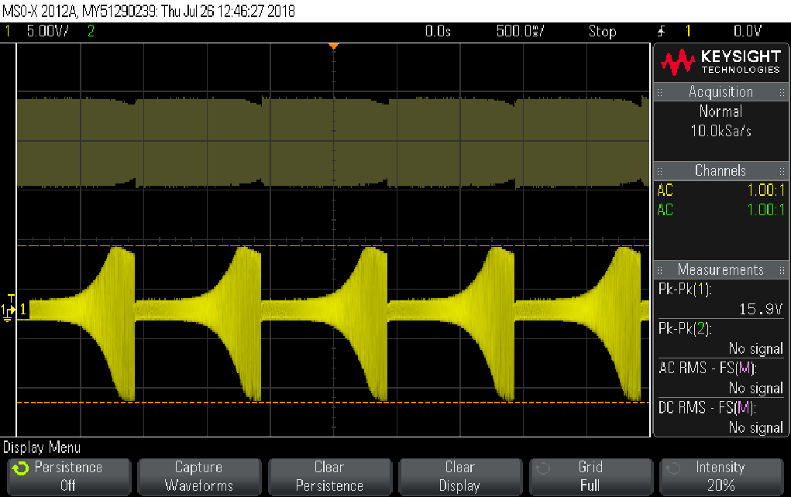

* 1. Without changing the circuit itself, perform a set of frequency measurements which would allow you to extract the value Rx. Explain and justify your steps. All calculations must be backed-up with scope print-outs (up to 3).

*Print #1: for extracting Rx*

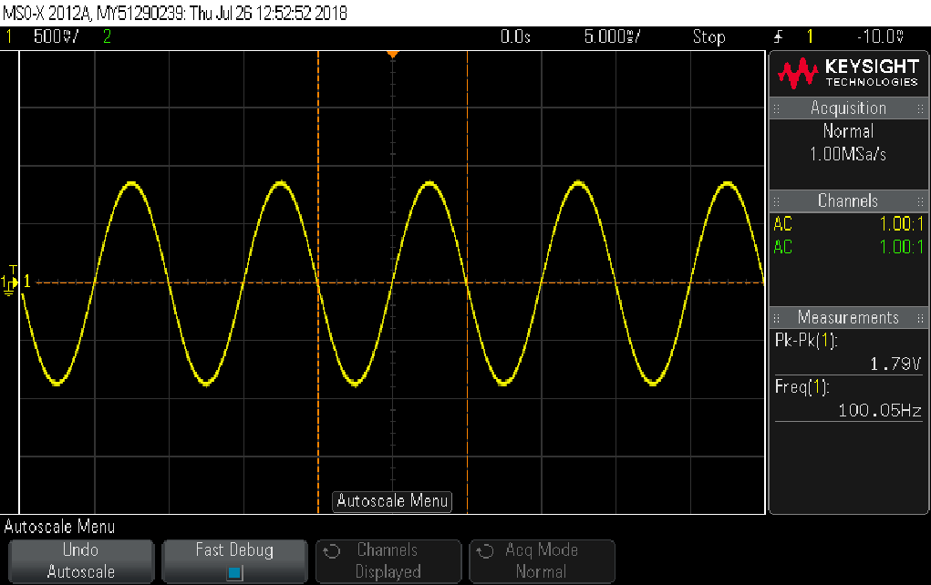

*Print #2: for extracting Rx (if needed)*

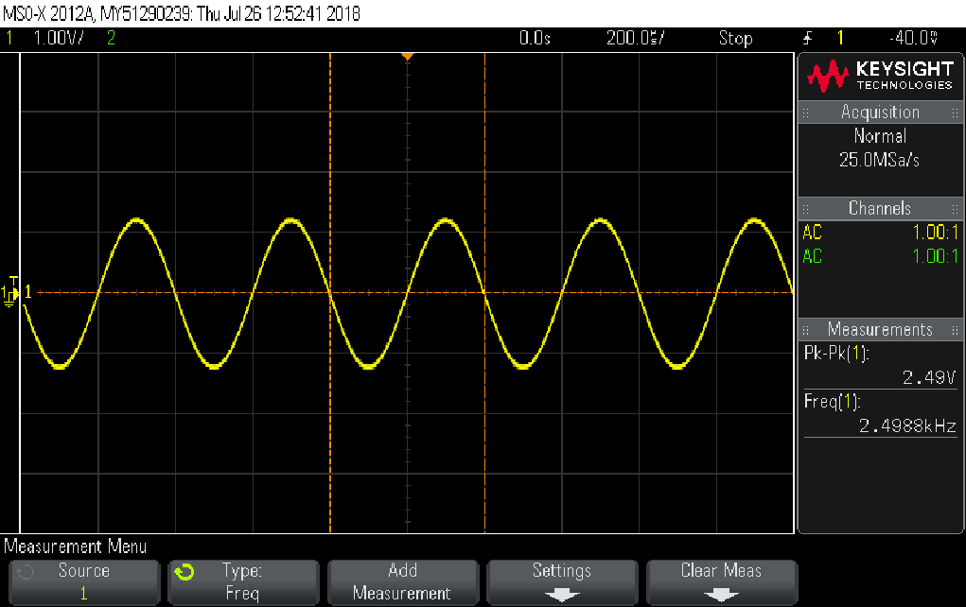

*Print #3: for extracting Rx (if needed)*

|  |
| --- |
| 1/(wz*C14)=21.237 kohm |
|  |
| תדר הברך שקיבלנו- 2.498KHz |
| מצאנו את המתח בתדר נמוך. לאחר מכן הכפלנו את ערכו פי שורש 2 ומצאנו את התדירות שמביאה אותנו לערך המתח שהתקבל. |
|  |
|  |

1. Single-Ended Differential Amplifier

* Refer to the preliminary report, section ‎5.

Build the circuit in Figure 8(b), according to the preliminary report. The circuit schematic is redrawn here for your convenience:



Figure 14

Measuring the dynamic range

* **Remember that for this section ONLY, set the board power supplies to +/-5V (or as close and symmetric as possible).**
* In the following you will want to measure the dynamic range of the circuit in several different ways. Make sure you understand what you’re doing!
* R4 and R5 are theoretically not needed, but used here for practical reasons of protecting the circuit against certain incorrect wiring or operating conditions.
  1. Quote the minimum and maximum input values you found in the preliminary report, section ‎5.6.

|  |  |
| --- | --- |
| 0V | 2V |
|  |  |

* 1. Connect a DC input signal, , using the waveform generator: in “waveform”, click the right most button (“MORE”) and choose “DC” as the waveform.
* **In the following, DO NOT use an input voltage , i.e. your measured input (on the scope’s CH1) should NOT be lower than -5V or higher than +5V.**
  1. Refer to section ‎5.6 in the preliminary report, and similarly find the range where all transistors are forward-active. Prove this with appropriate prints and measurements on them (up to four prints) of the input and output. Explain differences.

*Print #1: input and output*

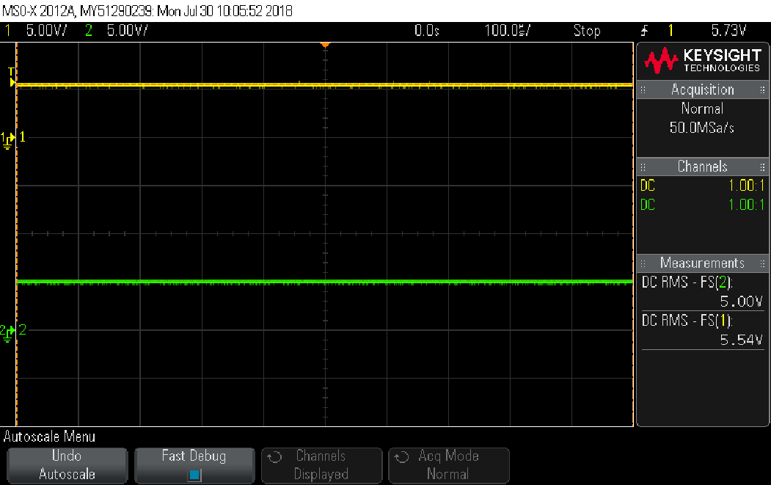

*Print #2: input and output (if needed)*

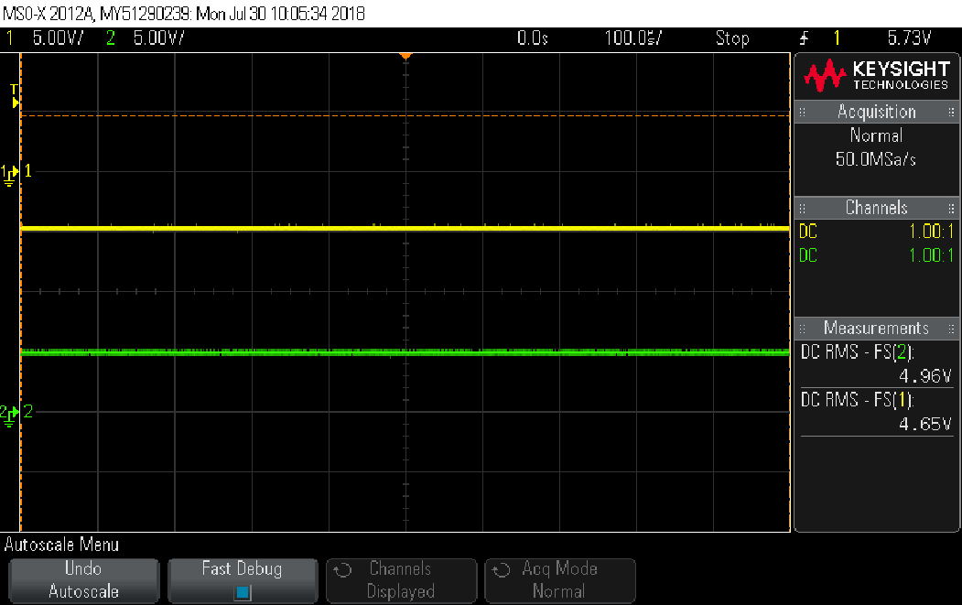

*Print #3: input and output (if needed)*

*Print #4: input and output (if needed)*

|  |  |
| --- | --- |
| -2.3V | 3V |
|  |  |

|  |
| --- |
| הכנסנו מתחים שונים לViDC עד אשר קיבלנו כי הטרנזיסטור נכנס לרוויה (במתחים גבוהים) או לקיטעון (במתחים נמוכים). כלומר, בין טווח המתחים שהתקבל אנו מקבלים הגברה של הטרנזיסטור ומחוץ לתחום זה מתקבל חוסר תפקוד של המעגל. |
|  |
|  |

* **In the following, your measured input (on the scope’s CH1) should NOT be lower than -5V or higher than +5V.**
  1. Now change the input signal to ramp/1kHz/50% symmetry with 0V offset and set the amplitude such that the output would become saturated on both ends. Display the output as a function of the input (XY mode), and change the scales such that the curve *fits the entire screen exactly*. Now, attach a print with cursors measuring the minimum limit and maximum limit of the dynamic range. The bottom right of the print should show the values of each cursor, i.e. “X1: .. X2: .. Y1: .. Y2: ..”. Can this be compared to the measurements in the previous sections? Explain. If yes, compare them.

*Print: input and output, minimum and maximum limit*

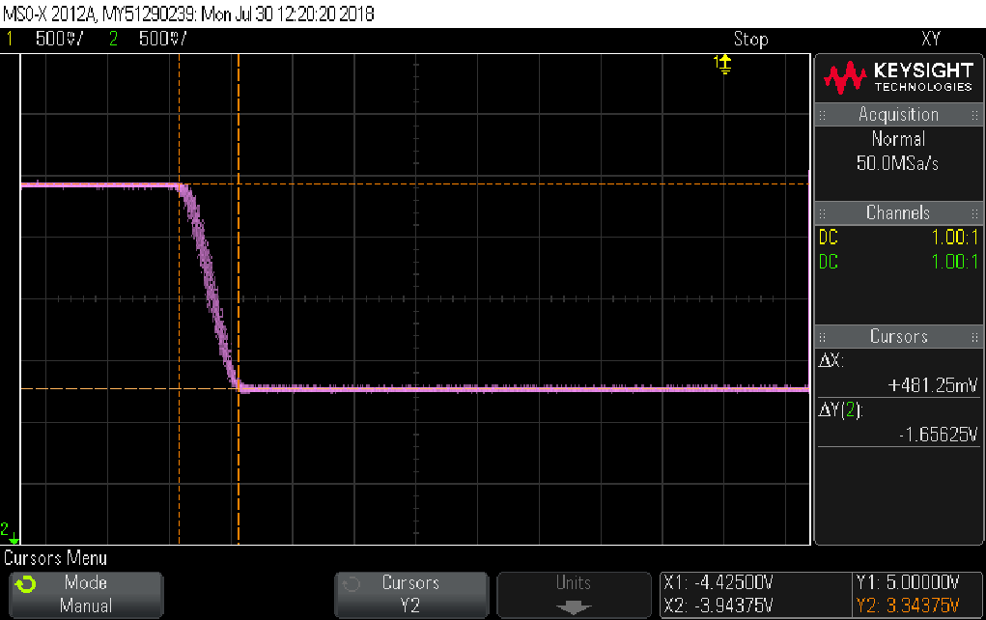

|  |  |
| --- | --- |
| -1.9715 | 2.212V |
|  |  |

|  |
| --- |
| תחמנו את התחום בו אות המוצא כפונקציה של הכניסה מקבל התנהגות לינארית. משם הסקנו את ViDC המינימלי והמקסימלי. |
|  |
|  |

* **In the following, your measured input (on the scope’s CH1) should NOT be lower than -5V or higher than +5V.**
  1. Now change the input signal to sine/1kHz and attach a print of the input and output in DC coupling, with MAX and MIN measurements for each (total of 4 measurements). Choose the input amplitude such that you may compare these measurement to the previous sections. Explain what’s happening, and compare.

*Print: input and output*

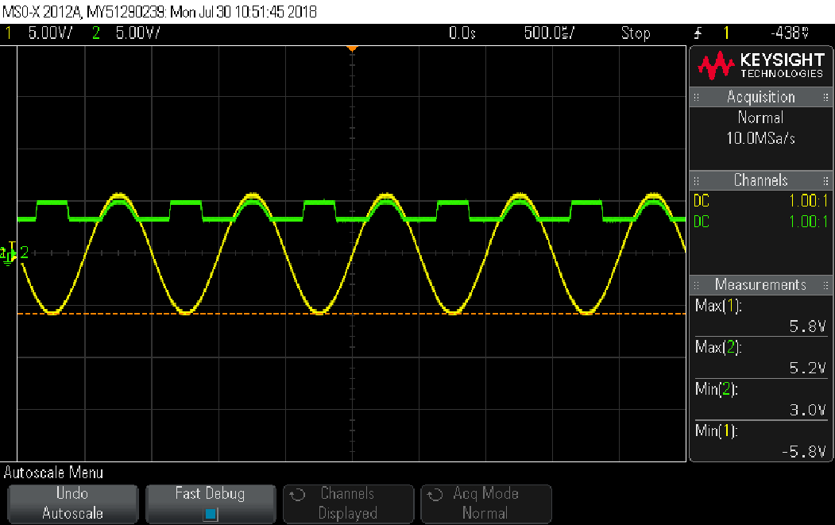

|  |
| --- |
| ניתן לראות כי הטווח שהתקבל עבור מתחי הכניסה דומים לטווחים שהתקבלו בסעיפים הקודמים. |
|  |
|  |

1. Three-stage operational amplifier

* Refer to the preliminary report, section ‎7.
* Make sure the board’s supply voltages are at +/-15V or as close and symmetric as possible.

Build the following circuit, based on the 3-stage opamp in the preliminary report, Figure 10:



Figure 15

* 1. For this section, replace the waveform generator vg with ground (physically disconnect the waveform generator from the board; do not to short-circuit it to ground!). Measure the circuit’s output and set the potentionmeter P3 relatively close to zero.
  2. Now, reconnect vg. Attach a print of the sweep, in DC coupling, with VPP measurements for the input and output signals (total of 2 measurements), and write down the sweep parameters in the table below.

|  |  |
| --- | --- |
| **SWEEP MEASUREMENT** | |
| Frequency range | 100HZ-3MHz |
| Sweep time | 1sec |
| Input voltage | 500mVpp |

*Print: input and output sweep*

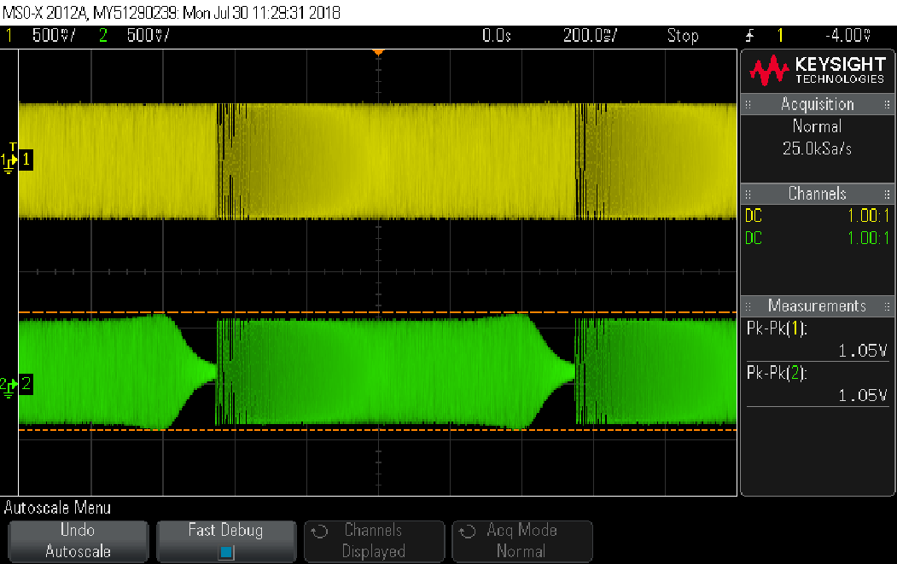

* 1. Find the -3dB frequency and attach a print of the input vg and output at this frequency, with frequency measurement for CH1, VPP measurements for CH1 and CH2, and a phase measurement (total of 4 measurements).

*Print: input and output*

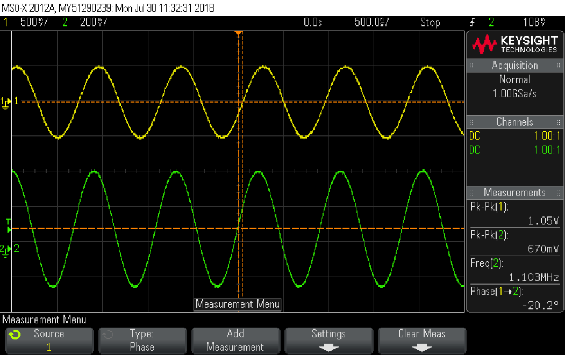

* 1. Estimate the DC open-loop gain. Use the following table measurement – fill the table’s column titles as you see fit (at least 5 measurement points; choose them wisely!).
* Forgot how to do it? Review the preliminary report, especially section ‎7.4.

|  |  |  |  |  |
| --- | --- | --- | --- | --- |
| **TABLE MEASUREMENT** | | | | |
| f Hz | Vg mvpp | Vy mvpp | Vout mvpp | AOL V/V |
| 2 | 400 | 21 | 390 | 1620.81 |
| 4 | 400 | 20 | 390 | 1717 |
| 6 | 410 | 21 | 390 | 1668.905 |
| 8 | 410 | 22 | 390 | 1579.273 |
| 10 | 420 | 18 | 400 | 2053.667 |

|  |
| --- |
| DC open-loop gain (estimation): 1727[V/V] (this is AOL average)=64.74[dB] |

* 1. Spectrum and THD measurement
     1. Set the input to square/3VRMS/1kHz/50% duty cycle. Display both input and output signals, and also the output’s spectrum, showing the first 5-10 harmonics. Attach a print which also shows the values of span and center that you chose. Then, attach another print with Vpp and frequency for the input signal, and Vpp and RMS for the output signal (total of 4 measurements).
* Always measure according to the “INFOBIT – How to measure a spectrum”! (see preliminary report sections ‎2.8-‎2.10).

*Print: input, output, and output’s spectrum with span and center*

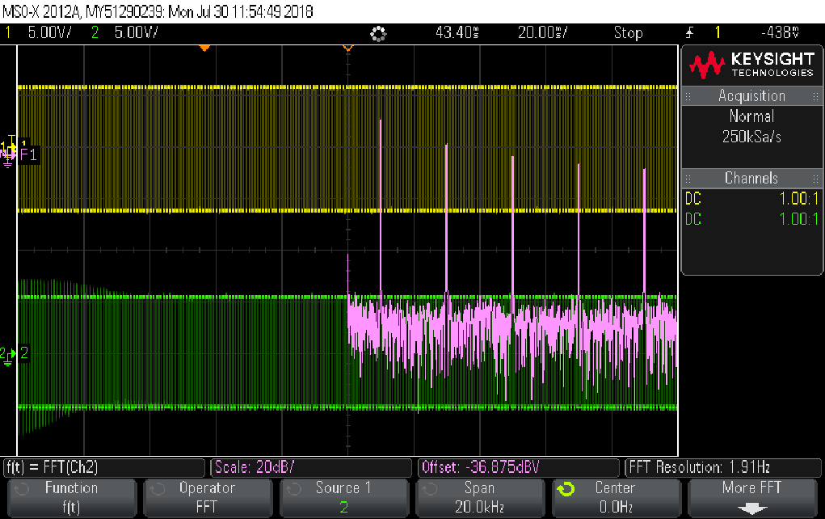

*Print: input, output, and output’s spectrum*

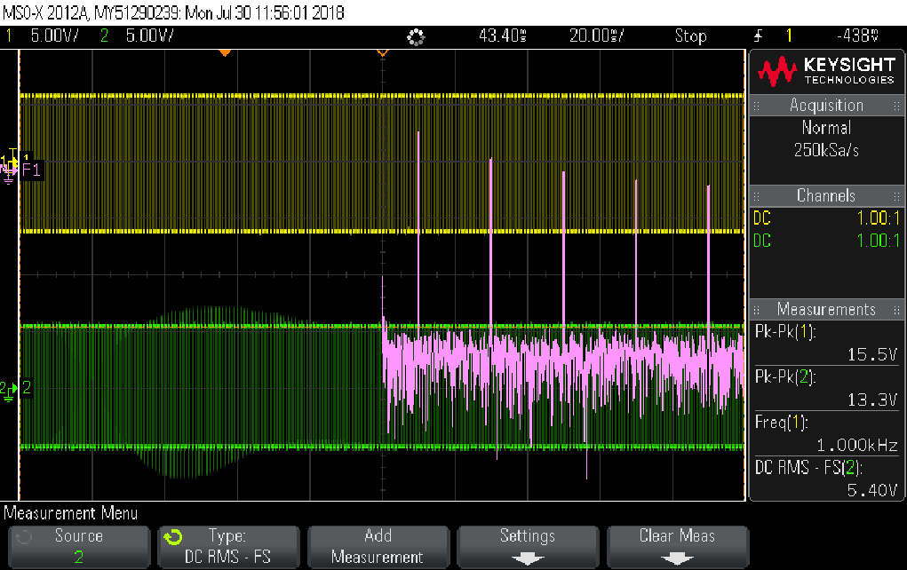

* + 1. Now use the cursors to correctly measure the harmonics of the output spectrum. Fill the table below to calculate the THD. Attach a print showing how you measure the difference between the first and second harmonics you measured for the table, showing the correct differences in height and in frequency.
    2. In the Excel table below, for each column, change “m” to the harmonic you measured.

*Print: input, output, and output’s spectrum, plus cursor measurements*

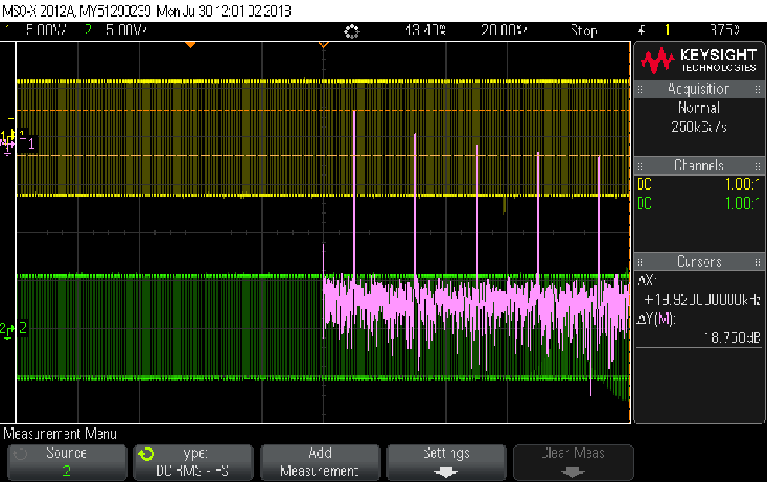

* For your convenience, the first harmonic is referenced as 0dB. Review the “INFOBIT – How to measure a spectrum “ document on the website, then fill the table below:



**This concludes experiment #2.**

**You have reached to end of this experiment: ask the lab guide to write down the time.**

**Hand in the preliminary report, and present the complete preliminary report of the next experiment before starting it.**